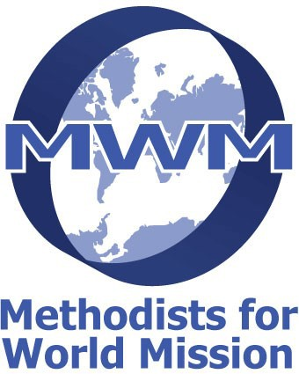
Methodists for World Mission (MWM)
Bethlehem Appeal
Charity No.243221
President: Rev. Inderjit Bhogal. Treasurer: Rev. John Howard
Tel. 01833 640823
john_d_howard@hotmail.com

Recognising the very difficult situation for the people of Bethlehem in early 2024, and especially the Christian Community - MWM is launching an appeal to support the people there. Working through organisations in the West Bank, which Methodism already supports we are able to get money to people with the minimum of administration (and costs borne by MWM). We anticipate that this fund will be open for a limited time.

Please support this appeal:

Online donations can be made to: Methodists for World Mission A/C 32545445
Virgin Money 05-02-42

Cheques payable to Methodists for World Mission can be sent to 13 Meadow Close, Middleton-in-Teesdale, Co Durham. DL12 0TW

Donations can be gift aided:
To gift Aid your donation either email (john_d_howard@hotmail.com) or send the following wording with cheque:

(Please only complete this if your gift is eligible for Gift Aid).

I confirm that my donation of £ xxx to Methodists for World Mission is eligible for gift aid.
I am a UK Tax Payer.

Name _________________________________________ Post Code ________________

Address _______________________________________ Date _____________________

