Spirit of Liberation - A World Mission conference focused on Latin America Swanwick 3rd - 5th June 2016 Booking Form | 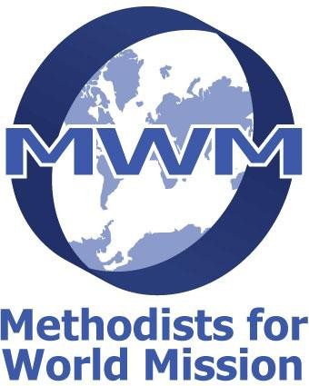 | Leave Blank

Please use a separate booking form for each room required
If 1st Timer | Title | Family Name |  | First Given Name |  |  |  | Gender |  |  | Postal Address |  |  |  |  |  |  |  | Post Code | Tel.No. | Age  (for student or child) | Fee  (see table overleaf)
--- | -- |  |  |  |  |  |  | - |  |  |  |  |  |  |  |  |  |  |  |  | ---
--- | -- |  |  |  |  |  |  | - |  |  |  |  |  |  |  |  |  |  |  |  | ---
--- | -- |  |  |  |  |  |  | - |  |  |  |  |  |  |  |  |  |  |  |  | ---
--- | -- |  |  |  |  |  |  | - |  |  |  |  |  |  |  |  |  |  |  |  | ---
--- | -- |  |  |  |  |  |  | - |  |  |  |  |  |  |  |  |  |  |  |  | ---
For day attendance Only  (insert total into the fee column) |  |  |  | Friday £5  (no meal) |  |  |  |  |  | Friday £20  (with meal) |  |  |  | Saturday £30  (with lunch) |  |  | Saturday £40  (with lunch & dinner) |  |  | Sunday £30  (with lunch)
Email Address |  |  |  |  | Address if invoiced elsewhere |  |  |  |  |  |  |  |  |  |  | Please tick if bursary allocated through district chair |  |  |  | Total Fees
 |  |  |  |  |  |  |  |  |  |  |  |  |  |  |  |  |  |  |  | Add - Guest Donation
Ensure that you complete your accommodation and dietary preferences |  |  |  |  |  |  |  |  |  |  |  |  |  |  |  |  |  |  |  | Grand Total
Non EnSuite |  | EnSuite |  |  |  |  |  |  |  |  |  | Sharing |  | Wheelchair Access | Difficulty with Stairs |  |  | Close to Doors or Lifts |  | Sum Enclosed
Single |  | Single | Double |  |  | Twin |  |  | Family |  |  |  |  |  |  |  |  |  |  | Balance Owed
Other Accommodation preferences, eg close to others (give name) |  |  |  |  |  |  |  |  |  |  |  | Special Diet requests / Allergies etc

Exhibitors: Name of Organisation | No./ Size of tables requested (eg 2L,1S)

By signing this form I understand that in making this booking I am liable for the Grand Total fee for the conference if I later have to cancel.
Signature Date:

If coming by car please offer lifts TO Conference if at all possible  State where from and no. of seats | Number of Lifts Offered FROM Alfreton Station | Lift required TO Conference (only available if there have been offers of lifts)  State where from

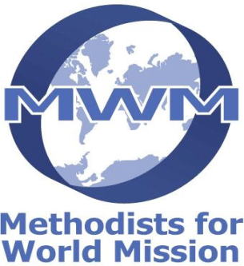
Methodists for World Mission

World Mission Conference 2016

3rd – 5th June 2016 at The Hayes Conference Centre, Swanwick

Spirit of Liberation

A world mission conference focused on Latin America.

Programme

Friday
4pm to 6pm Registration
5.30pm MWM AGM
Evening session after supper
Saturday
Morning keynote speakers and discussion
Bible study
Afternoon choice of workshops
Evening regional themed celebration
Sunday
Morning final session including worship
Depart after lunch

Conference Fees - per person Residential
EnSuite (Single, Double, Twin or Family) |  | £150
Non ensuite (Single) |  | £120
(£5 discount on the above rates if booked before 18th March)
Young people 14-16 and students 17-25 years |  | £70
Children | 6 – 13 years | £32
 | 2 – 5 years | £16
 | Under 2 years | free

Day Visitors
Friday | inc supper | £20 | without supper | £5
Saturday | inc lunch | £30 | inc lunch & supper | £40
Sunday | inc lunch | £30

Accommodation
Please ensure that any special requirements are entered on the booking sheet, and that the booking is made as early as possible. It may be impossible to meet requests made close to the conference start date.

Special family discounts
Families with three or more children in full time education can claim a 100% discount for third and subsequent children.

Guest donations
These are required to help fund overseas guests and bursaries. Please give generously.

Bursaries
Bursaries can be considered for young people and others whose work, service or education might benefit from their attendance. Assistance may be given to cover part or all the conference fee, and travel.
Funds for this purpose are limited; please enquire before completing the booking form.

First attendance discounts
For those with responsibilities for the promotion of World Mission in local congregations, and who are attending the conference for the first time, a 20% discount is available. We encourage congregations, circuits, districts, deaneries and diocese to consider sponsoring representatives.

Terms and Conditions
No booking is secure until full fees are paid. Final payment must be received by 16th May 2016, after this date bookings not secured by full payment may be offered to others on the waiting list and your booking cancelled by us. Cancellation, after 16th May 2016, will normally lead to the loss of a scaled proportion of the money paid (£25 of which is a non-returnable deposit). You are advised to take out Travel Insurance to cover cancellation costs.

Travel Arrangements
The nearest rail station is Alfreton. If arriving at Alfreton or Derby a reliable taxi company is Amber Taxis 01773 836100. As a guide, they charge (pre-booked) £25.00 from Derby and £6.00 from Alfreton (please quote 'The Hayes' to ensure these rates- check when booking).
Lifts to the conference may be available, please complete the relevant part of the booking form. Sign up lists for lifts from the conference will be available during the conference.

Enquiries
Please contact:

Email: allansmithmwmbookings@gmail.com

Tel: 01929471412

Booking and Payment
The booking form must be accompanied by either the full fee, or a non – returnable deposit of £25 per person.

Please make cheques payable to “METHODISTS FOR WORLD MISSION”, and return the booking form by post to:

Allan Smith, 7 Bladen Valley, Briantspuddle, Dorchester, Dorset DT2 7HP

